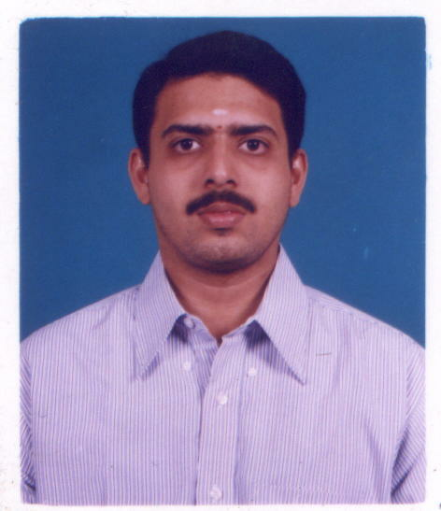

Mahesh Inna Kedage

W-48/D, Type III, Ambedkar Circle,

Anna Nagar West, Phone: Resi: 91-044-26160659

Chennai-600040 Mobile: +91 98411 33820

E-mail: ikmahesh555@yahoo.co.in Passport Number: E1734104.

OBJECTIVE

An engineering position where I can contribute my technical and interpersonal skills developed from my childhood.

EXPERIENCE

April 2002: Field training in general features of transmission and digital switching
equipment’s, accomplished at BSNL, Chennai.

EDUCATION

Graduated from NMAMIT- Nitte, Visveswariah Technological University, B.E. Electronics and Communication in June 2003,
April 1998: Higher Secondary School Examination
April 1996: Matriculation Examination.

PROJECTS PROFILE

“Unmanned Ground Vehicle for Hazardous Operation” Nov 2002 to June 2003
Final year academic project

Abstract

This is class C archetype Unmanned ground vehicle. This vehicle consists of control unit and vehicle unit. Vehicle is maneuver by wireless transmission of signals in AM and FM modulation. The vehicle consists of in built robotic arm with capacity of lifting a weight of around 500 Gms. The vehicle is operated wireless in the range of about 95 MHz strength for a distance about 200 Mts.

Role
- Implemented the DTMF encoder and decoder circuits.
- Mechanical design and infrastructure of the vehicle.

COMPUTER EXPERTISE

Programming Languages: Core-java, VS COBOL II
Database Applications: DB2
Operating Systems: DOS, MVS (Z/OS, 390/OS), Win 9x, Win XP
Web Technologies: Servlets, JSP, Java Beans
Database Connectivity: JDBC
Front Hand OLTP: CICS
Batch Control Language: JCL.
Data Access Methods: VSAM
Tools: TSO/ISPF, SPUFI, DCLGEN

HONORS:

- During my final grade of my schooling, I was holding the office of School Pupil leader.
- Presented a paper titled “Implementation of VLSI using VHDL Tools” in an Inter-college
symposium.
- My Final year project has been published in Indian Express Mangalore Edition Dated 2nd August
2003.
- Taken lot of informative class seminars like “Ipv6 addressing” in my final semester.

Extracurricular Activities:

- Associate member of Animal Protection Group (Reg. No.594/1994)
- Keen cricket and Basketball player.
- Represented School, District Level and played in state-level tournaments.

Personal Details:

Date of Birth: 15th July 1980
Sex : Male
Nationality : INDIAN

References:

Will be provided on demand

Place: Chennai
Date: 01-09-2003. Signature: InnaKedage Mahesh

